**1.Open CMP:** [**http://marketplace.citigroup.net/**](http://marketplace.citigroup.net/)

**2.Click “Myself” and type the person’s name or login id that who need software and search!**

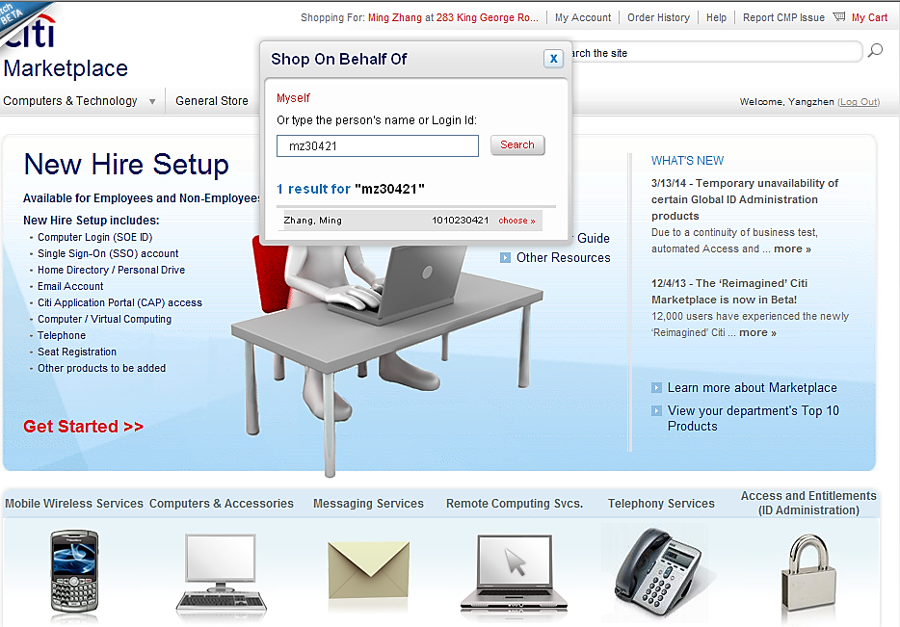**Then choose the person! (if you shopping for yourself, you do not need to do this)**

**3.Click”NO.1000,Chenhui….”and change your location (Nam address).**

**if you don’t know your Nam address/ P2P Approver/P2P expense code, you could login:** <http://gdir.nam.nsroot.net/globaldir_new/GDIR_Result_Detail.aspx?webGEID=1010494672&Redirect=Y>

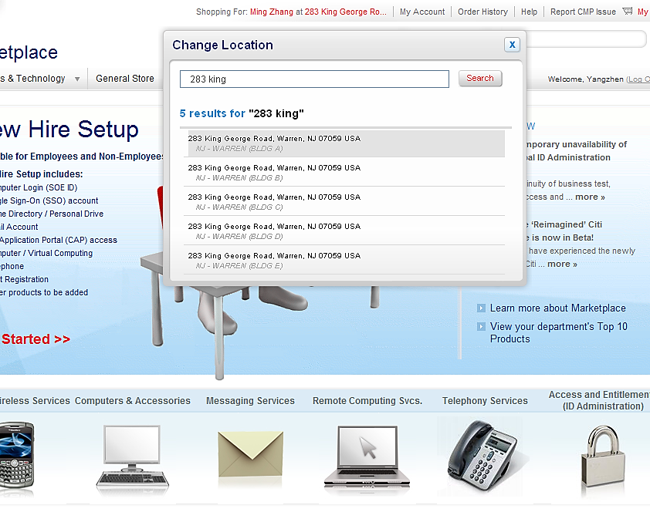**entering your Nam college’s name or SOEID to find yours**

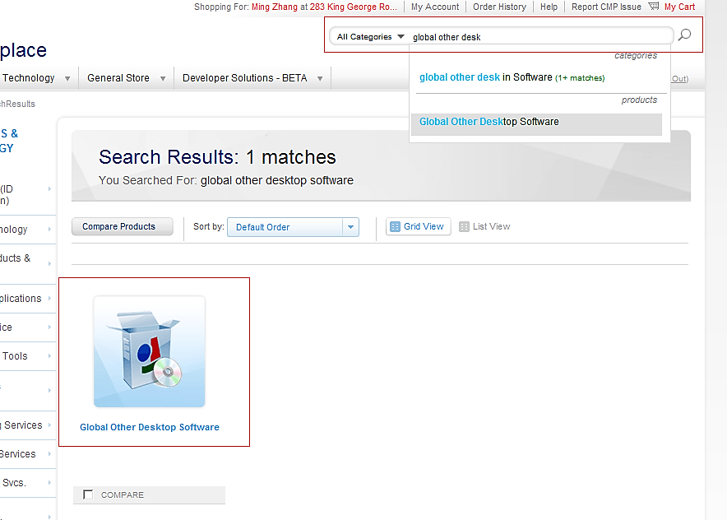**4.Type “global other desktop software” and choose the right one.**

**5.You will see the page like blew**

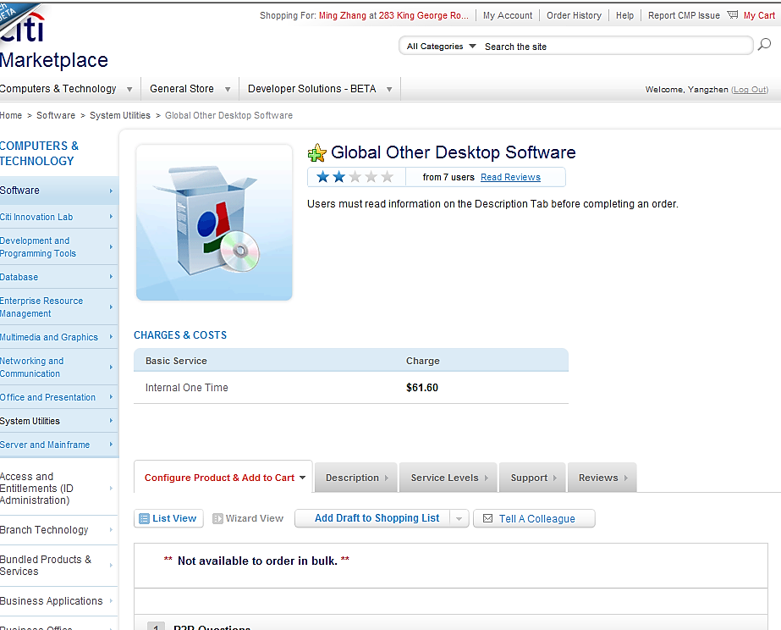

**6.Click update and choose your p2p approver (please do not choose Chen, Ching-yu).**

**if you don’t know your Nam address/ P2P Approver/P2P expense code, you could login:** <http://gdir.nam.nsroot.net/globaldir_new/GDIR_Result_Detail.aspx?webGEID=1010494672&Redirect=Y>

**entering your Nam colleague ’s name or SOEID to find yours**

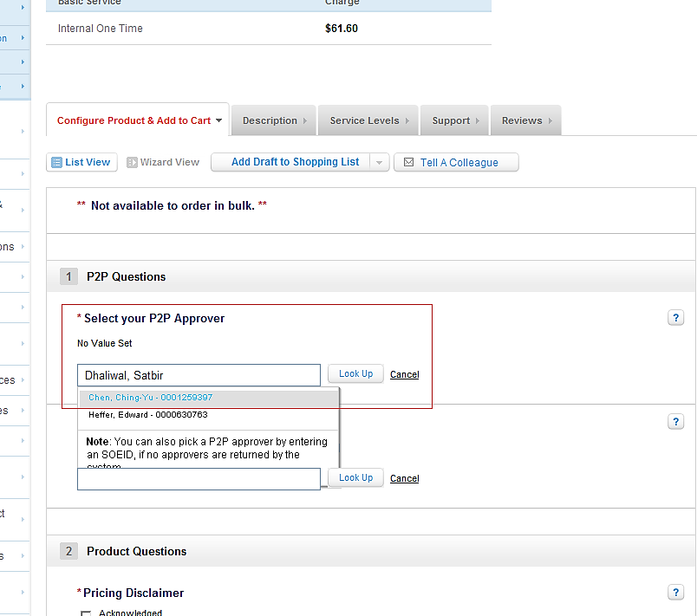

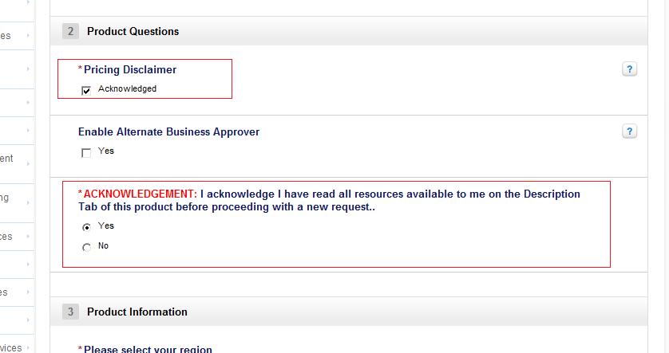**7.”Pricing Disclaimer” is Acknowledged and “acknowledgement” is yes**

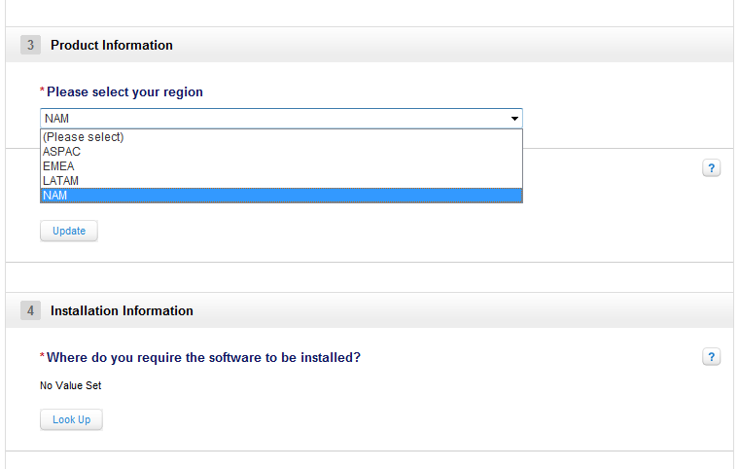**8.Choose your region, NAM**

**9.entering the software name that you want to install ,click “look up” and find the right one**

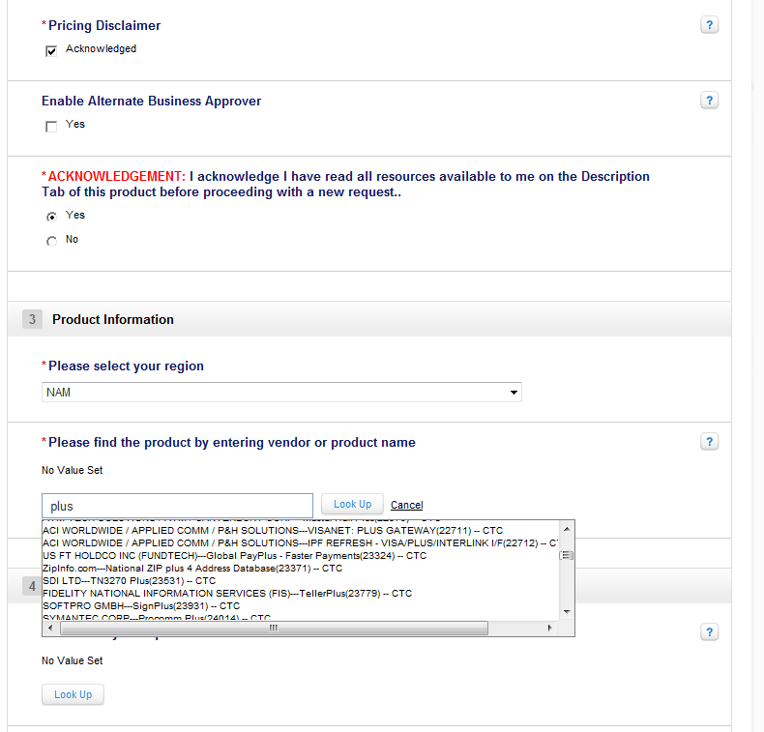

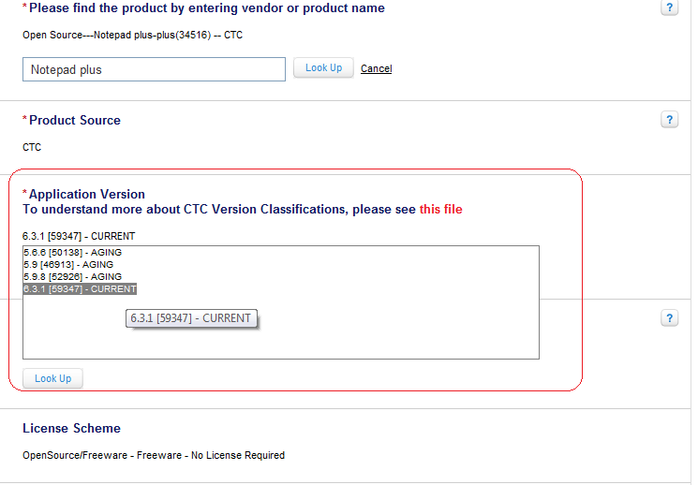**10.Click “look up” to select the version that you need and choose the right one**

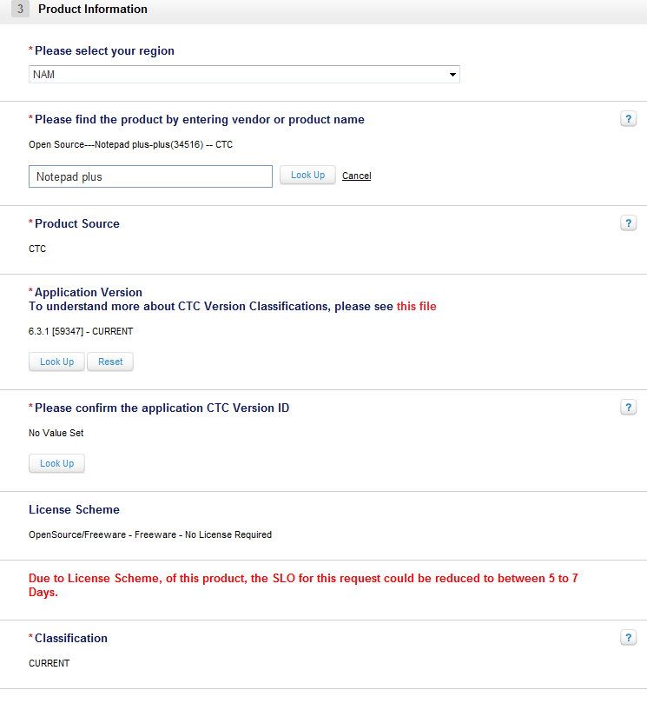**11. you will see the page like below**

12.Click”look up” to select where do you require the software to be installed

**12. Click “look up” to choose the VDI machine ID**

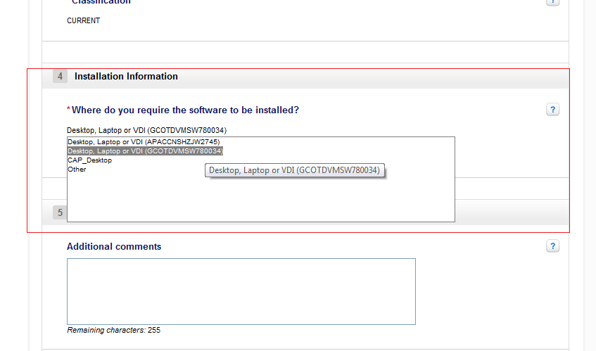

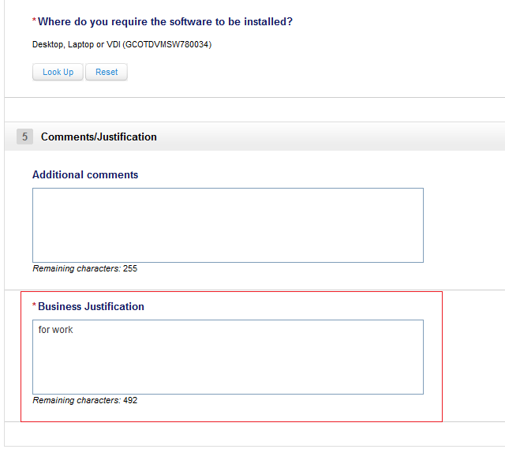**13.”Business Justification” you can enter like “for work” ,”for VDI” and so on.**

**14.Click”Quick Order” and Submit Order**

